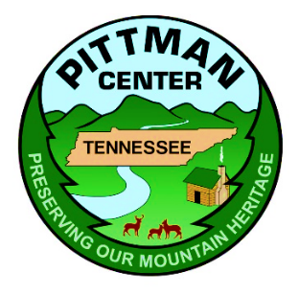

TOWN OF PITTMAN CENTER, TENNESSEE
MEETING OF THE BOARD OF MAYOR AND ALDERMEN
September 18, 2025
Agenda

- Call the meeting to order

- Roll Call

- Invocation

- Pledge Allegiance to The Flag

- Special Presentations:

- Approval of August 21, 2025, Meeting minutes

- Citizen Comments

- Chief of Police Report

- City Administrator Report

Old Business – Review Beer Board Discussion

- New Business:

- Review and discuss the Bid results for the FY2026 Resurfacing Project
- Review and discuss the need to reduce the speed limit on Emerts Cove Road
- Review and discuss the possibilities of Food Trucks within the Town
- Review and discuss the building permit fees

- First Reading and Consideration of Ordinance No. 341 An Ordinance of the Town of Pittman Center, Tennessee for Provisions for illuminated Open Signs Within the Town of Pittman Center

- First Reading and Consideration of Ordinance No. 342 An Ordinance Amending the “Zoning Map of the Town of Pittman Center, Tennessee” by Rezoning Properties from the RLD (Low Density Residential) District to the C2 (General Commercial) District
- Other Business

Adjourn

